

How to Leverage Project Server 2007 with PerformancePoint Server 2007 Monitoring and Analytics
Author:
William G. Brown - Symmetry Corporation
Date published:
January 2009
Summary:
This whitepaper provides an overview of the PerformancePoint Server software and how it can be used to develop dashboards with the existing Reporting and Analysis Services databases created with Project Server 2007.


http://www.symcorp.com

The information contained in this document represents the current view of Microsoft Corporation on the issues discussed as of the date of publication. Because Microsoft must respond to changing market conditions, it should not be interpreted to be a commitment on the part of Microsoft, and Microsoft cannot guarantee the accuracy of any information presented after the date of publication.

This White Paper is for informational purposes only. MICROSOFT MAKES NO WARRANTIES, EXPRESS, IMPLIED OR STATUTORY, AS TO THE INFORMATION IN THIS DOCUMENT.

Complying with all applicable copyright laws is the responsibility of the user. Without limiting the rights under copyright, no part of this document may be reproduced, stored in or introduced into a retrieval system, or transmitted in any form or by any means (electronic, mechanical, photocopying, recording, or otherwise), or for any purpose, without the express written permission of Microsoft Corporation.

Microsoft may have patents, patent applications, trademarks, copyrights, or other intellectual property rights covering subject matter in this document. Except as expressly provided in any written license agreement from Microsoft, the furnishing of this document does not give you any license to these patents, trademarks, copyrights, or other intellectual property.

Unless otherwise noted, the companies, organizations, products, domain names, e-mail addresses, logos, people, places, and events depicted in examples herein are fictitious. No association with any real company, organization, product, domain name, e-mail address, logo, person, place, or event is intended or should be inferred.

© 2009 Microsoft Corporation. All rights reserved.

Microsoft, Windows, Excel, SharePoint, PerformancePoint, and the Office logo are trademarks of the Microsoft group of companies.

All other trademarks are property of their respective owners.

Table of Contents
Table of Figures 1
Introduction 2
What is Microsoft Project Server 2007 Reporting and Analysis? 2
Microsoft Business Intelligence Technology Stack 5
What is PerformancePoint Server? 6
Monitoring 6
Analytics 6
Planning 6
Benefits of PerformancePoint Server with Project Server 7
Key Benefits 7
PerformancePoint Monitoring Architecture 7
PerformancePoint Monitoring Terminology 8
Data Sources 8
Indicators 8
KPIs (Key Performance Indicators) 8
Scorecards 9
Reports 9
Dashboards 9
Creating a Project Server Dashboard 10
Create the Data Sources 11
Create the Role 11
Assign Access to the Database 11
Assign Access to the Cubes and Dimensions 12
Create Indicators 15
Create KPIs 15
Indicators and Scoring Engine 16
Define Data for Actual 16
Define Data for Targets 17
Target Calculation 17
Prior Period Calculation 18
Compare to All Project Calculation 19
Other KPIs 20
KPI Name 20
Description 20
Data Source 20
MDX Formula 20
Target 21
Scoring Pattern, Banding Method and Indicator 21
Objective 21
Scorecard 22
Reports 25
MDX 25
MDX 25
Dashboard 26
Filters 26
PerformancePoint Monitoring Conclusions 27
PerformancePoint Analytics 27
Grid 28
Analytic Features 28
Visualization 30
Calculations 31
PerformancePoint Analytics Conclusion 32
Summary 32
Sample data files 32
References 33

Table of Figures

Figure 1 – Microsoft Project Server Data Flow 4
Figure 2 – Microsoft Business Intelligence Technology Stack 5
Figure 3 – PerformancePoint Functions 6
Figure 4 – PerformancePoint-Monitoring Architecture 8
Figure 5 – KPI Builder 9
Figure 6 - Dashboard 10
Figure 7 – Data Source Connecting to Assignment Timephased Cube 14
Figure 8 − Indicators 15
Figure 9 – KPI Definition Window 16
Figure 10 – Project Risk 17
Figure 11 – Project Risk Target Threshold 18
Figure 12 – Project Risk Prior Period Threshold 19
Figure 13 – Project Risk Compared to All Projects Threshold 20
Figure 14 – CPI Target Threshold 21
Figure 15 – Objectives 21
Figure 16 – High Risk Scorecard 22
Figure 17 – High Risk Scorecard Available Items 23
Figure 18 – Custom Sets 23
Figure 19 – High Risk Projects 24
Figure 20 – Trend Graph 25
Figure 21 – Bar and Line Graph 25
Figure 22 – PerformancePoint-Analytics Grid 28
Figure 23 – PerformancePoint-Analytics Filter 29
Figure 24 – PerformancePoint-Analytics Sorting 29
Figure 25 – PerformancePoint-Analytics Results 30
Figure 26 – PerformancePoint-Analytics Decomposition Tree 30
Figure 27 – PerformancePoint-Analytics Perspectives 31

Introduction

This white paper provides an overview of the Microsoft PerformancePoint Server software and how it can be used to develop dashboards with the existing relational and analytical databases created with Microsoft Office Project Server 2007 (Project Server). In addition to detailing some advanced techniques for creating analytically rich scorecards, it covers how to organize Key Performance Indicators (KPIs) and other best practices.

While the paper does not cover Project Server in detail, it does explain critical functionality that helps facilitate using the reporting and analytical environment.

What is Microsoft Project Server 2007 Reporting and Analysis?

Project Server works with Microsoft Project Professional and Project Web Access (PWA) and allows collaboration between project managers, team members and project sponsors. Project Server enables organizations to store project and resource information centrally and consistently. It also integrates with Microsoft Windows SharePoint Services 3.0 for file management and collaboration capabilities, helping team members to work together more effectively. Further, based on their roles, users can access data and functionality via the Internet with Microsoft Office Project Web Access.

Project Server stores data in four Microsoft SQL Server databases: the Draft, Published, Archive, and Reporting databases. The Reporting database is designed for near real-time, read-only access for generating reports. The Reporting database is tightly synchronized with the Published database. The Published database contains all published plans, timesheets, and metadata, including:
- Resource and user definitions
- Custom field definitions
- Lookup table definitions
- Timesheet data and definitions
- Calendar definitions
In addition, the Reporting database also contains data extracted from the following lists in project workspace sites:
- Project issues
- Project risks
- Project deliverables
The On-Line Analytical Processing (OLAP) database for Project Server includes a total of 14 default cubes for Enterprise Project Management (EPM) reports, rather than the one cube as in earlier Project Server versions. The following are the eight primary EPM cubes:
- Project Non-Timephased
- Task Non-Timephased
- Resource Non-Timephased
- Resource Timephased
- Assignment Non-Timephased
- Assignment Timephased
- Timesheet
- EPM Timesheet
The following are the three default Windows SharePoint Services cubes:
- Risks
- Issues
- Deliverables
The Reporting database allows for reporting against a simpler schema than the one created for data capture. The Analysis Services database allows for fast and robust analysis of the project data. Project Server frequently updates the data in the OLAP cubes based on the scheduled times that are set in the Cube Build Settings page in Project Web Access. The Analysis Services database will be critical for a successful PerformancePoint Server implementation.

Creating the Analysis Services database is covered in the Project Server documentation on TechNet and is not covered in this paper.

Please see the Microsoft Office Project 2007 Software Development Kit (SDK) for more information on the schemas for the Reporting database and the OLAP cubes structures.

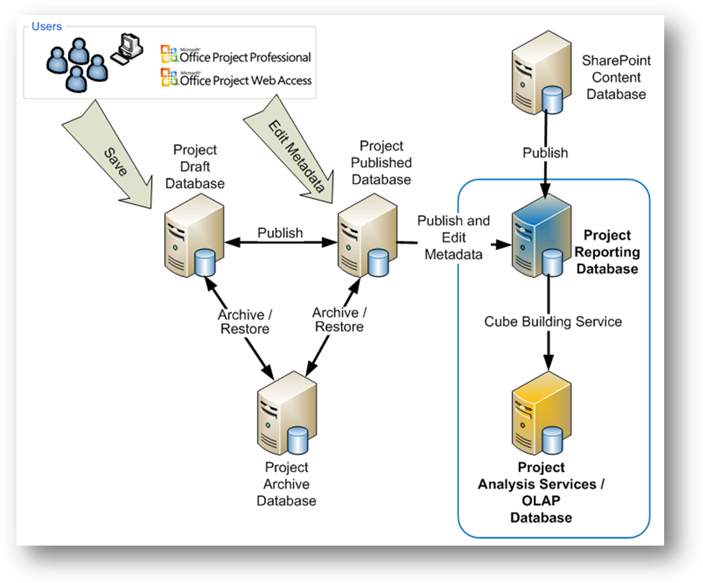
Figure 1 – Microsoft Project Server Data Flow

Microsoft Business Intelligence Technology Stack

The Microsoft Business Intelligence (BI) technology stack includes Microsoft Office (with a focus on Excel for BI and performance management), Office SharePoint Server or Windows SharePoint Services (for collaboration), PerformancePoint Server (with Monitoring, Analytics, and Planning), and SQL Server (with Reporting Services, Analysis Services, and Integration Services).

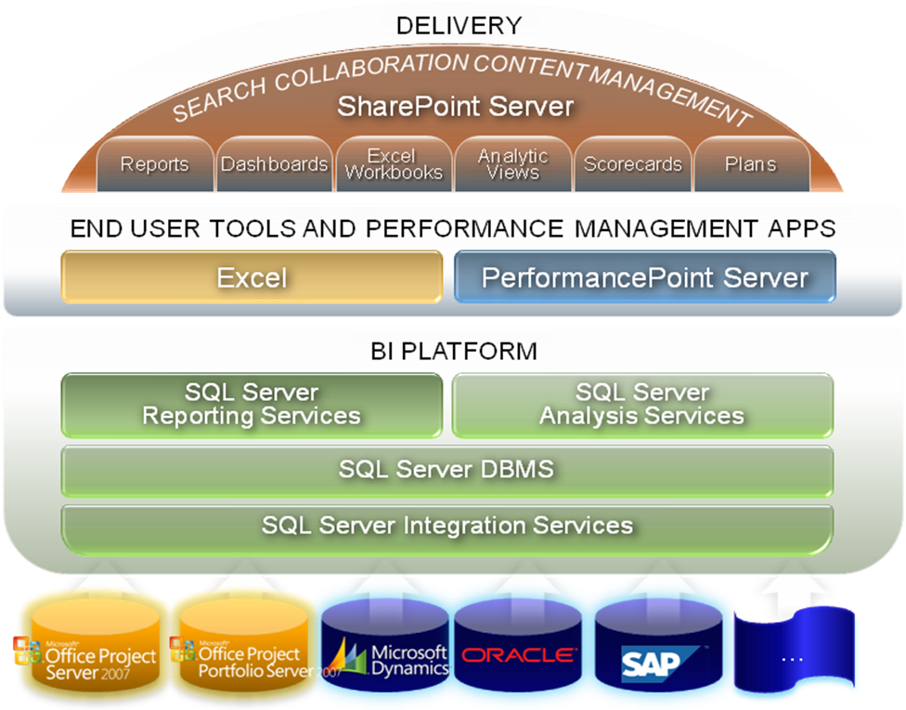
Figure 2 – Microsoft Business Intelligence Technology Stack

Analysis Services is the foundation of PerformancePoint Server. Although PerformancePoint Server will work with many different data sources, Analysis Services is required to take full advantage of PerformancePoint Server Monitoring, Analytics, and Planning. With Analysis Services as the analytical database, end users can access data that could be coming from data sources as disparate as SQL Server, Oracle, and SAP. The functionality of Analysis Services is critical for any PerformancePoint application. In this white paper, when Analysis Services is referenced, it refers to the Analysis Services database created by Project Server.

What is PerformancePoint Server?

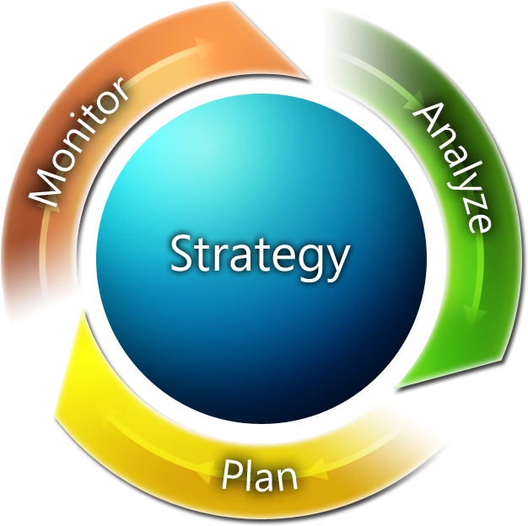
PerformancePoint Server is a suite of BI applications that acts as a platform for performance management. Together those applications solve a range of BI problems. PerformancePoint Server allows an organization to monitor, analyze and plan its business. Users can publish objectives and track performance against those objectives, explore and discover insights into the company’s data, and plan for the future. PerformancePoint Server uses the Microsoft BI stack with emphasis on SQL Server Analysis Services in particular.
The suite of PerformancePoint Server applications allows an organization to focus on organizational objectives. Each of the three applications supports the other, resulting in a process that is stronger than any single application in isolation.
Figure 3 – PerformancePoint Functions

Monitoring

PerformancePoint Monitoring is the main focus of this paper. PerformancePoint Dashboard Designer, a PerformancePoint Monitoring application, enables the creation of Key Performance Indicators (KPIs), scorecards, dashboards, and reports and then displays them with Office SharePoint Server or Windows SharePoint Services. PerformancePoint Monitoring Server includes a scoring engine that aggregates KPIs together to track to specific objectives.

KPIs are those metrics needed to track the performance of a team, department, and/or organization. Possible project management KPIs are Time against Baseline, Work against Baseline, and Estimate at Completion.

Objectives are aggregations of KPIs or other objectives that map to organizational or departmental goals. In a Project Server environment, possible objectives include Projects on Track and Proactively Manage. Objectives can also be aligned with business goals such as Improve Customer Satisfaction and Reduce Returns.

Analytics

PerformancePoint Analytics provides users with the ability to explore data stored in the Analysis Services database without having to know how to write code-specific queries. The fast query response and robust filtering of PerformancePoint Analytics allows for virtually unlimited access to the data. Patterns can be discovered and problems found and then added to PerformancePoint Monitoring Server to highlight actions that need to be taken to resolve issues. If actions are defined in the Analysis Services cube, users can use these actions in the analytic reports.

This paper will cover PerformancePoint Analytics functionality and provide examples of ad-hoc analysis.

Planning

PerformancePoint Planning allows for the creating of budgets, strategic plans, forecasts, and what-if analysis. The planning functions in Project Server can be supplemented with PerformancePoint Planning. PerformancePoint Planning can also be used to gather data not in Project Server.

This white paper will only provide an overview of PerformancePoint Planning with Project Server.

Benefits of PerformancePoint Server with Project Server

The same improvements that Business Intelligence has provided for Sales, Marketing, IT, and Finance can be provided for Project data. Project Server is an excellent tool for planning and tracking project implementations. The reporting database and the reports that are part of the Project Server SDK provide a tactical view of the projects. However, to understand the reports, users need to have a detailed understanding of project management. Not everyone is clear how a project aligns to the business goals. PerformancePoint Server enables a broader user community to access the data by aligning projects with objectives, integrating data from other data sources, establishing targets, and providing navigation paths through the data.

Key Benefits
- PerformancePoint Server allows Project Server data to be aligned with business goals. Projects can be grouped into various objectives that align with corporate goals.

- Other data not stored in Project Server can be added to the PerformancePoint Designer application, giving users a much broader view of the project’s health and impact.

- Targets communicate how KPIs are performing against organizational benchmarks and how the data is trending. Targets not only indicate direction but the impact of the direction. Sales are good when trending up, while expenses are bad when increasing.

- Navigation gives users a path to investigate the data. Project management experts can use PerformancePoint to create KPIs, scorecards and dashboards that encompass their expertise, thereby making it possible to share their knowledge with a wide user community. By exposing the project knowledge to a broad audience, the project management process is improved. Clear and consistent reporting allows users to spend less time on gathering data and more time investigating the data.

- Ad hoc capabilities give users the tools to explore the data. The multidimensional database provides fast and flexible access to the data. With ad hoc access, business users can investigate the data instead of depending on canned reports or developers to create reports.

PerformancePoint Monitoring Architecture

The PerformancePoint Monitoring architecture is straightforward. The Dashboard Designer is the primary design and management tool. It is used to build and publish XML definitions of all the dashboard objects. The dashboard objects are stored in a SQL Server database. The Monitoring web service retrieves the objects from the database, queries the data sources and renders the results to the users using SharePoint Web Parts.

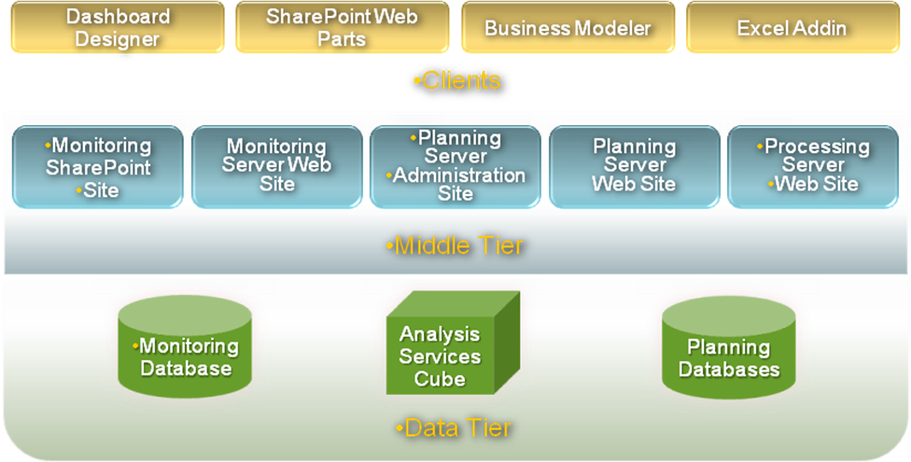
Figure 4 – PerformancePoint-Monitoring Architecture

PerformancePoint Monitoring Terminology

A scorecard is built with a set of objects created with the Dashboard Designer. Each of these objects is used to create dashboards that can be deployed to Office SharePoint Server or Windows SharePoint Services.

PerformancePoint Monitoring objects include:

Data Sources
Data Sources contain the connection strings to query various structured data sources. KPIs and reports use Data Sources to retrieve data. Possible Data Sources include Analysis Services, Excel, SharePoint lists and ODBC databases. However, reports must be sourced from Analysis Services cubes.

Indicators

Indicators display visual prompts that reflect the status of KPIs and/or Objectives. Indicators use icons, colors, or text to display status.
Each target of a KPI can have an indicator. Indicators include stoplight, trend arrows, gauges and thermometers. Developers can create their own indicators as well.

KPIs (Key Performance Indicators)

KPIs are the main building blocks of any scorecard. KPIs are the critical factors to track in order for an organization to drive improvement.
KPIs use data from one or more Data Sources for comparison and/or calculation purposes. KPIs use Indicators to provide visual prompts and provide context to the data. KPIs report one Actual value and, typically, one or more Target values. Actual values reflect what happened, while targets provide a context for interpreting the data.
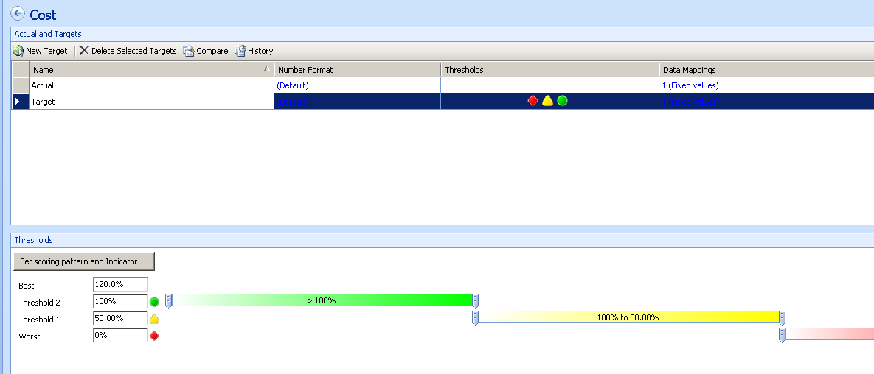
Figure 5 – KPI Builder
The actual data and target data of KPIs can be sourced from Excel, SharePoint lists, ODBC compliant databases, and Analysis Services cubes, or can be manually entered.

In scorecards, objectives are rollups or aggregations of KPIs. Objectives are special KPIs that are sourced from other KPIs. The PerformancePoint Monitoring Server engine uses its own scoring engine to aggregate KPIs into objectives.

Scorecards

A scorecard is assembled from one or more KPIs organized hierarchically. Scorecards can also display dimensional data when the data source is an Analysis Services database.

Reports

Reports display business data in many different formats. Reports can display grids, graphs, Reporting Services reports, and PerformancePoint Analytics reports.

Dashboards

Dashboards bring all the elements together by exposing the data contained in scorecard and reporting elements. They are the delivery mechanism to the end user in Office SharePoint Server or Windows SharePoint Services via the Dashboard Item web part. Dashboards contain all the logic used to control what the user sees and how they can interact with the elements contained therein.

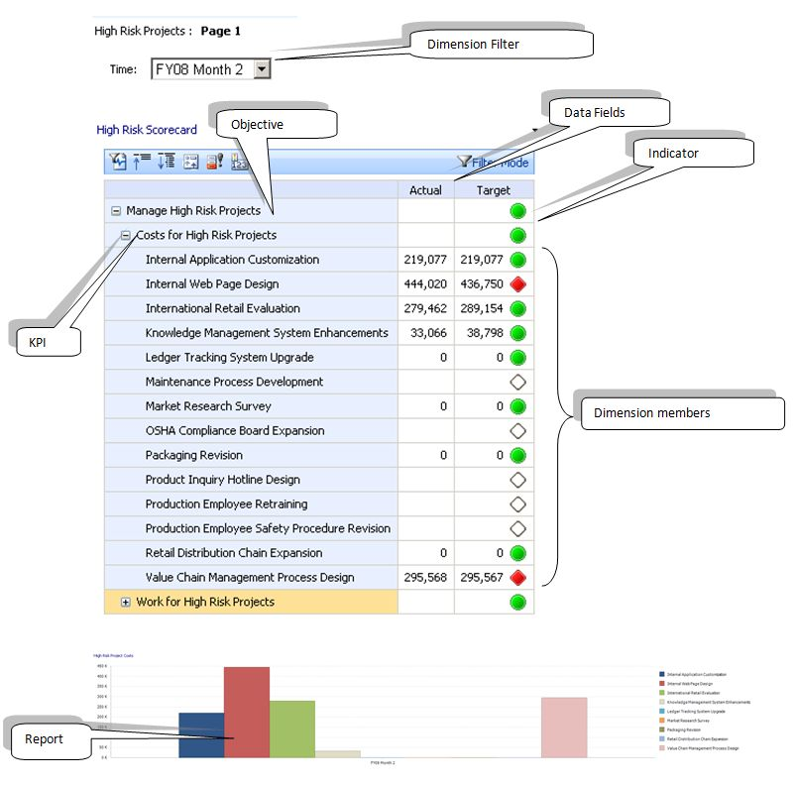
Figure 6 - Dashboard

Creating a Project Server Dashboard
This section documents the techniques for creating Dashboards with Project Server as a data source. It does not cover the exact PerformancePoint Server-specific steps, but documents changes and approaches required to use Project Server data effectively.
Creating a dashboard includes the following steps:

Create the Data Sources

While creating a data source is a simple task, one issue needs to be clarified. The Monitoring Server Web Service connects to the Analysis Services cube using the Windows Network Service account. Adding the Network Service account to an Analysis Services role is a straightforward task, however the Project Server database is often deleted and recreated. When this happens, any changes (such as security changes) to the Analysis Services database are lost.

In order to create the Analysis Services role programmatically, the following XMLA commands need to be issued. XMLA is a language for maintaining the Analysis Services databases. Note: These commands are for example purposes only and will require changes for your cubes.

Create the Role
The following XMLA creates the role in Analysis Services:

<Create xmlns="http://schemas.microsoft.com/analysisservices/2003/engine">
<ParentObject>
<DatabaseID>epm2007Demo</DatabaseID>
</ParentObject>
<ObjectDefinition>
<Role xmlns:xsd="http://www.w3.org/2001/XMLSchema" xmlns:xsi="http://www.w3.org/2001/XMLSchema-instance" >
<ID>PPSRole</ID>
<Name>PPSRole</Name>
<Members>
<Member>
<Name>NT AUTHORITY\NETWORK SERVICE</Name>
</Member>
</Members>
</Role>
</ObjectDefinition>
</Create>

Assign Access to the Database

The following XMLA links the role to the database and sets several security attributes.

<Batch xmlns="http://schemas.microsoft.com/analysisservices/2003/engine">
<Alter AllowCreate="true" ObjectExpansion="ObjectProperties">
<Object>
<DatabaseID>epm2007Demo</DatabaseID>
</Object>
<ObjectDefinition>
<Database xmlns:xsd="http://www.w3.org/2001/XMLSchema" xmlns:xsi="http://www.w3.org/2001/XMLSchema-instance" xmlns:ddl2="http://schemas.microsoft.com/analysisservices/2003/engine/2" xmlns:ddl2_2="http://schemas.microsoft.com/analysisservices/2003/engine/2/2">
<ID>epm2007Demo</ID>
<Name>epm2007Demo</Name>
<Description>Project Server Site UID: b3c8f488-7074-4a19-8d80-0878f4fc2dad</Description>
<Language>1033</Language>
<Collation>Latin1_General_CI_AS</Collation>
<DataSourceImpersonationInfo>
<ImpersonationMode>Default</ImpersonationMode>
</DataSourceImpersonationInfo>
</Database>
</ObjectDefinition>
</Alter>
<Alter AllowCreate="true" ObjectExpansion="ExpandFull">
<Object>
<DatabaseID>epm2007Demo</DatabaseID>
<DatabasePermissionID>DatabasePermission 1</DatabasePermissionID>
</Object>
<ObjectDefinition>
<DatabasePermission xmlns:xsd="http://www.w3.org/2001/XMLSchema" xmlns:xsi="http://www.w3.org/2001/XMLSchema-instance" xmlns:ddl2="http://schemas.microsoft.com/analysisservices/2003/engine/2" xmlns:ddl2_2="http://schemas.microsoft.com/analysisservices/2003/engine/2/2">
<ID>DatabasePermission 1</ID>
<Name>DatabasePermission 1</Name>
<RoleID>PPSRole</RoleID>
<Read>Allowed</Read>
</DatabasePermission>
</ObjectDefinition>
</Alter>
</Batch>

Assign Access to the Cubes and Dimensions
The XMLA below assigns access to the cube and dimensions. The example code below is a subset of the XMLA required. Each cube and every dimension needs to be included. This example only includes one cube and two dimensions.
<Batch xmlns="http://schemas.microsoft.com/analysisservices/2003/engine">
<Create AllowOverwrite="true" xmlns="http://schemas.microsoft.com/analysisservices/2003/engine">
<ParentObject>
<DatabaseID>epm2007Demo</DatabaseID>
<CubeID>Assignment Timephased</CubeID>
</ParentObject>
<ObjectDefinition>
<CubePermission xmlns:xsd="http://www.w3.org/2001/XMLSchema" xmlns:xsi="http://www.w3.org/2001/XMLSchema-instance">
<ID>PPSRole</ID>
<Name>PPSRole</Name>
<RoleID>PPSRole</RoleID>
<Read>Allowed</Read>
<ReadSourceData>None</ReadSourceData>
</CubePermission>
</ObjectDefinition>
</Create>
<Alter AllowCreate="true" ObjectExpansion="ObjectProperties" xmlns="http://schemas.microsoft.com/analysisservices/2003/engine">
<Object>
<DatabaseID>epm2007Demo</DatabaseID>
<DimensionID>Task List</DimensionID>
<DimensionPermissionID>DimensionPermission</DimensionPermissionID>
</Object>
<ObjectDefinition>
<DimensionPermission xmlns:xsd="http://www.w3.org/2001/XMLSchema" xmlns:xsi="http://www.w3.org/2001/XMLSchema-instance" xmlns:ddl2="http://schemas.microsoft.com/analysisservices/2003/engine/2" xmlns:ddl2_2="http://schemas.microsoft.com/analysisservices/2003/engine/2/2">
<ID>DimensionPermission</ID>
<Name>DimensionPermission</Name>
<RoleID>PPSRole</RoleID>
<Read>Allowed</Read>
</DimensionPermission>
</ObjectDefinition>
</Alter>

<Alter AllowCreate="true" ObjectExpansion="ObjectProperties" xmlns="http://schemas.microsoft.com/analysisservices/2003/engine">
<Object>
<DatabaseID>epm2007Demo</DatabaseID>
<DimensionID>Assignment Owner</DimensionID>
<DimensionPermissionID>DimensionPermission</DimensionPermissionID>
</Object>
<ObjectDefinition>
<DimensionPermission xmlns:xsd="http://www.w3.org/2001/XMLSchema" xmlns:xsi="http://www.w3.org/2001/XMLSchema-instance" xmlns:ddl2="http://schemas.microsoft.com/analysisservices/2003/engine/2" xmlns:ddl2_2="http://schemas.microsoft.com/analysisservices/2003/engine/2/2">
<ID>DimensionPermission</ID>
<Name>DimensionPermission</Name>
<RoleID>PPSRole</RoleID>
<Read>Allowed</Read>
</DimensionPermission>
</ObjectDefinition>
</Alter>
</Batch>

The XMLA can be executed with SQL Server Integration Services or using the ASCMD utility (see references at the end of the paper).

Once the security issues are resolved, the next step is to create the data sources. Using the Dashboard Designer, simply click on the Data Sources field and add a new data source. One data source will have to be created for each cube created.

Below is a picture of a data source that connects to the Assignment Timephased cube.
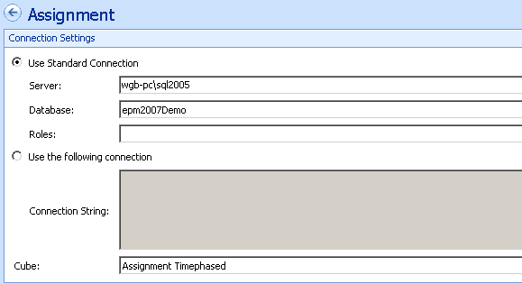
Figure 7 – Data Source Connecting to Assignment Timephased Cube

Create Indicators

Indicators are visual indicators of the KPI status. Indicators can be shared by several KPIs, however there are two basic types of indicators: Standard and Centered.

Standard indicators are used when the KPI actual value is either higher than the target or lower than the target. For example, Cost Performance Index is best when the actual value is above the target value. Project Cost is best when it is below the target value.

Centered Indicators are used when the KPI’s value should be as close to the target as possible. Actual values that are too high or too low require a visual warning. These KPIs include Headcount, Schedule Performance Index, and Cost Variance.

Below is a picture of several Standard Indicators that will be used later when creating a KPI.

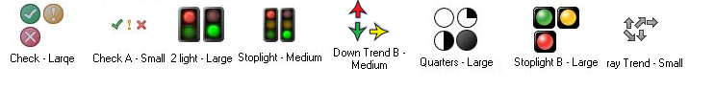
Figure 8 − Indicators

Create KPIs

KPIs are numbers that are critical to the success of a company, a department, or a project. Before starting to create a KPI, the developer should understand where the data comes from and which type of indicator to use (Standard or Centered).

To create the KPI we simply create the KPI and name it. The KPI definition window will appear.
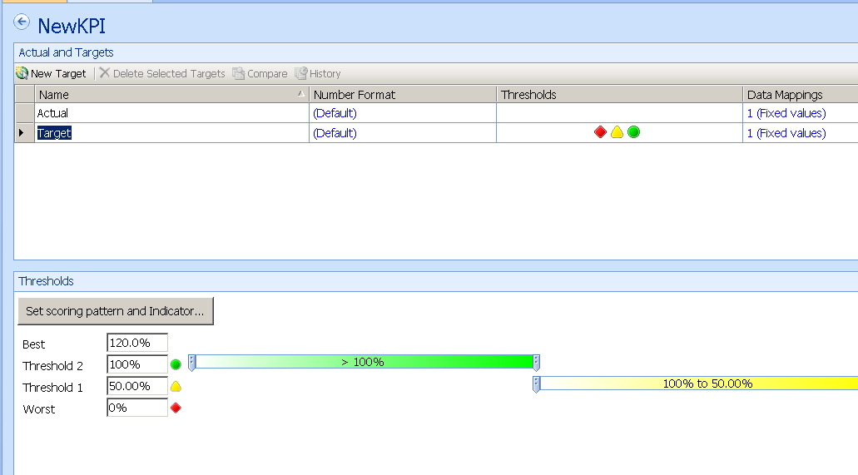Figure 9 – KPI Definition Window
By default there are two data elements: Actual and Target. Each has its own Data Mapping. The Data Mapping screen allows for the developer to manually enter a number or to connect to a Data Source. In these examples the data source will be one of the Project Server cubes.

Indicators and Scoring Engine

In each of the targets an indicator and thresholds need to be set. These settings are used to calculate the KPI score that sets the indicator. The KPI score is a normalized value based on the KPI settings and data. The normalized score allows the KPI to be compared to other KPIs and aggregated into an Objective. Understanding how the indicators and scoring works is beyond the scope of this white paper. The resources section of the white paper includes a link to a blog post that explains the basics of the scoring engine.
A detailed explanation of the scoring engine is beyond the scope of this white paper.

For completeness, each target definition will include the settings for the thresholds.

Define Data for Actual

The first step is changing the data source and choosing which measure to display. The data can be further narrowed down by selecting specific dimension members from any related dimension. This would allow a KPI to be generated for High Risk Project Costs by selecting Measure Project Costs and the member RISK from the dimension GOV Risk Project Level as shown in the picture below.
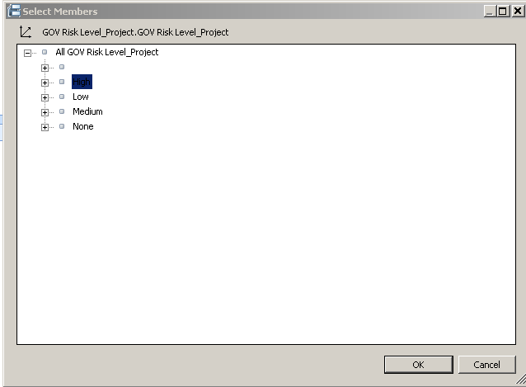
Figure 10 – Project Risk
The Actual value does not have any indicators.

Later, during the creation of the Dashboard, we will apply a time filter to show data from a specific month.

Define Data for Targets

Dashboard Designer allows for the creation of many targets for any KPI. The source for each target can be the same data source as Actual, a different data source or a manually input number. In many cases not every KPI you define will have a corresponding target value. In the example High Risk Project Costs, we can display data from the measure Baseline Work Costs. In other examples, there might not be a baseline number. Targets can also be derived using MDX.

Expanding the High Risk Project Cost KPI that was started in the above section, the example will add three new scorecard target calculations.

Target Calculation

This Project Risk Threshold target is almost identical to the Actual value, except instead of using the measure Actual Cost, the measure Baseline Cost is used.
Scorecard Setting | Value
Scoring Pattern: | Decreasing is Better
Banding Method: | Band by Normalized Value of Actual/Target
Indicator: Stoplight | Stoplight
Worst Value: 0 | 0

Scorecard Thresholds | Value
Best: | 0.00%
Threshold 1: | 80.00%
Threshold 2: | 90.0%
Worst: | 120.0%
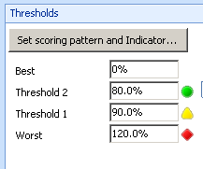
Figure 11 – Project Risk Target Threshold

Prior Period Calculation

The prior period calculation is based on Actual Costs for the prior period. By using an arrow indicator we can see how costs are doing compared to the baseline and in which direction they are moving.
In this example, the calculation will be defined as an MDX Tuple Formula as follows:

([Measures].[Actual Cost], [Fiscal Time].[Fiscal Time].currentmember.lag(1),[GOV Risk Level_Project].[GOV Risk Level_Project].[High])

The MDX formula is simple but requires explanation. It returns the Actual Cost data for High Risk Projects. It takes the current time period selected and displays the data from one period back. The current time period is set with a filter when the dashboard is created.

Scorecard Setting | Value
Scoring Pattern: | Decreasing is Better
Banding Method: | Band by Normalized Value of Actual/Target
Indicator: Stoplight | Down Trend - Large
Worst Value: 0 | 0

The indicator selected is a 5 value indicator and has more threshold settings.
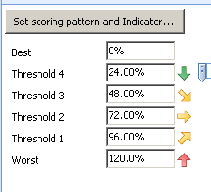
Figure 12 – Project Risk Prior Period Threshold

Compare to All Project Calculation
The Compare to All Projects calculation is an average of Actual Costs for projects of all risk types. This compares the average cost of all projects against the costs of high risk projects.

In this example, the calculation is defined as an MDX Tuple Formula as follows:

([Measures].[Actual Cost],[Project List].[All Project List]) /
descendants(
{[Project List].[Project List].[All Project List]} ,888,leaves).count

The MDX is somewhat more complex.

The first section displays the cost for every project, regardless of whether a specific project is displayed on the Scorecard.

([Measures].[Actual Cost],[Project List].[All Project List])

The second section divides the Actual Cost by the count of projects.

descendants(
{[Project List].[Project List].[All Project List]} ,888,leaves).count

Scorecard Setting | Value
Scoring Pattern: | Decreasing is Better
Banding Method: | Band by Normalized Value of Actual/Target
Indicator: Stoplight | Stoplight
Worst Value: 0 | 0

The indicator selected is a 5 value indicator and has more threshold settings.
Figure 13 – Project Risk Compared to All Projects Threshold
A second KPI can be created using Actual Work and Baseline Work with the same settings.

Other KPIs

An effective scorecard can have dozens of KPIs. The following set of KPIs will allow for the creation of a robust dashboard and cover several techniques of creating KPIs.

KPI Name

Cost Performance Index (CPI)

Description

CPI is a measure of the cost efficiency of a project. It is defined as the project’s Budgeted Cost of Work Performed (BCWP) divided by the Actual Cost of Work Performed (ACWP).

The BCWP and ACWP data required for CPI is in the Assignment Non Timephased cube. The Assignment Non Timephased cube does not have a time dimension, as it represents the most recent data and no historic trending is allowed. Because it does not have a time dimension, this KPI cannot have any time filters linked to it. If an unrelated dimension is linked to a KPI, an error message will be returned.

Data Source
Assignment Non Timephased

MDX Formula

iif (coalesceempty( [Measures].[ACWP] ,0)=0 , null,
[Measures].[BCWP]/[Measures].[ACWP])

Target

The target for CPI is 1. A 1 indicates that that the cost of the project is on plan. A CPI that is over 1 indicates that the plan is under budget. Note however that it might also indicate that the plan has a poor baseline requiring a re-examination of the base assumptions.

Scoring Pattern, Banding Method and Indicator

Scoring Pattern: Closer to Target is Better

Banding: Band by normalized value of Actual/Target

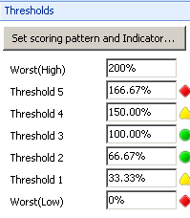
Figure 14 – CPI Target Threshold

Objective

An objective is an aggregation of KPIs. Objectives are created like KPIs, but instead of linking the objective to data, the objective is calculated on the scorecard. In the example, the objective “Manage High Risk Projects” is created.

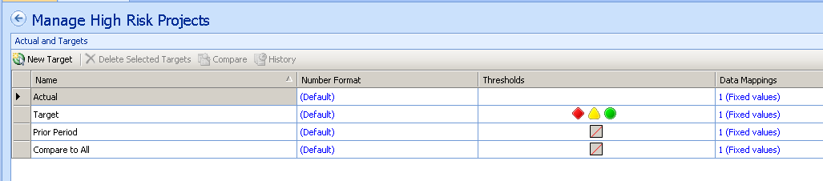
Figure 15 – Objectives
Once the Objective is created the next step is to create a scorecard.

Scorecard

With two KPIs and an objective, the next step is to create a scorecard.

A scorecard assembled from the KPIs “Costs for High Risk Projects” and “Work for High Risk Projects”, and an aggregate objective of “Manage High Risk Projects” is below.

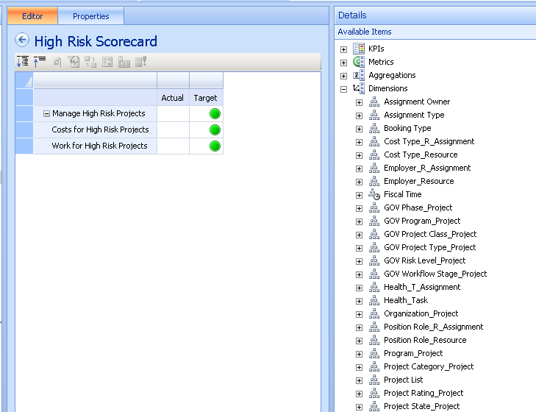
Figure 16 – High Risk Scorecard
It is possible to add dimension members to the scorecard from the “Available Items” menu on the right.

Dimension members can be added by dragging over specific members one at a time. This allows for objectives to be created from an arbitrary list of projects.

In other cases the list of projects could be changed dynamically. In the High Risk Projects example, the list of projects would be those flagged as High Risk. As each project’s risk level is updated, the list of projects will change.

During the scorecard creation, there are several options at the bottom of “Available Items.”

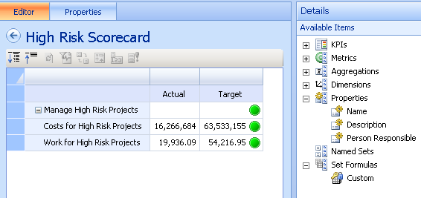
Figure 17 – High Risk Scorecard Available Items
The last two items are Named Sets and Set Formulas. Sets are lists of dimension members which can either be static or dynamic. Named Sets are sets created in the Analysis Services database directly. By default, the Project Server cubes do not have any named sets.

PerformancePoint allows for the creation of sets to be used on a scorecard. Unlike named sets, these sets are not shared between scorecards. Each scorecard must have its own sets created. Also, once a set is created in PerformancePoint, the statement cannot be changed or viewed.

Creating set formulas requires the use of MDX. In our Manage High Risk Scorecard, the developer might want to list all the high risk projects under each KPI. Clicking on the Custom option as shown in the figure below, and dragging it over to the KPIs as shown will bring up the Set Formula Editor.

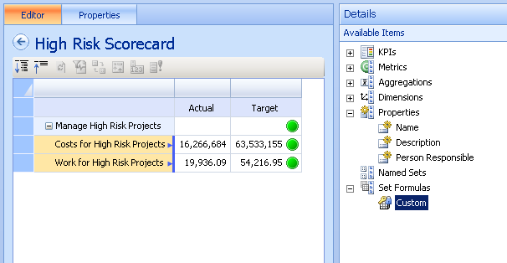
Figure 18 – Custom Sets
The Set Formula editor is a window that allows developers to enter an MDX statement that returns a list of dimension values. For example, to return the list of High Risk Projects, use the following MDX:

exists(
descendants([Project List].[All Project List], 8888, leaves),
[GOV Risk Level_Project].[GOV Risk Level_Project].[High],
"Assignment Timephased")

This will result in the following scorecard.

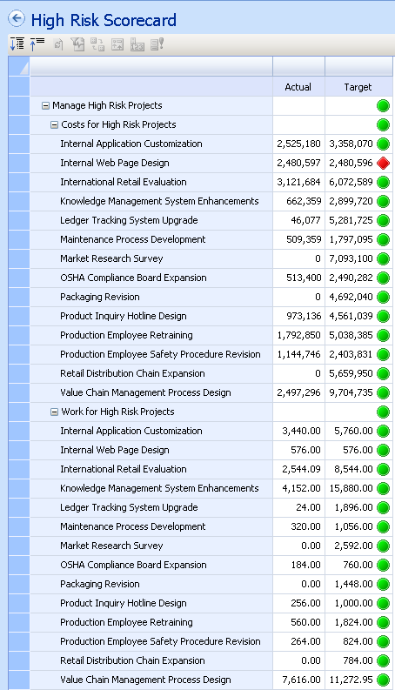
Figure 19 – High Risk Projects

Reports

Reports are traditional views of data using grids and graphs. These reports help explain the KPI and provide context for the KPI. The report design has a drag-and-drop interface and can accept MDX statements, thereby allowing for a powerful range of reports.

For example, the trend graph can show a KPI’s direction over time.

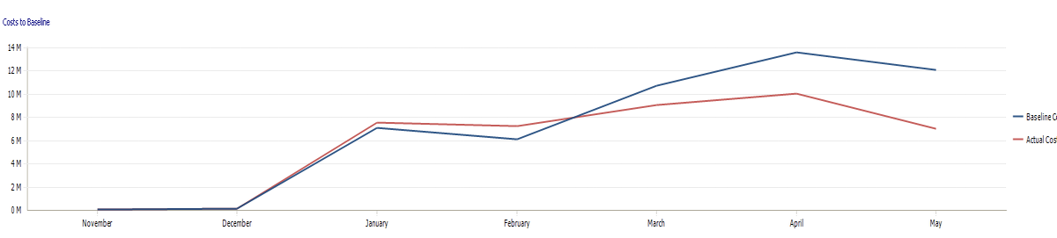
Figure 20 – Trend Graph

MDX

SELECT
<<Time>>.lag(6):<<Time>> ON COLUMNS ,
{ [Measures].[Baseline Cost], [Measures].[Actual Cost] } ON ROWS
FROM [Assignment Timephased]

The MDX displays Baseline and Actual Cost for the user-selected month and the last six months. The <<Time>> parameter is passed in from the Dashboard filter.

A bar graph of related projects analyzes the project against similar projects.

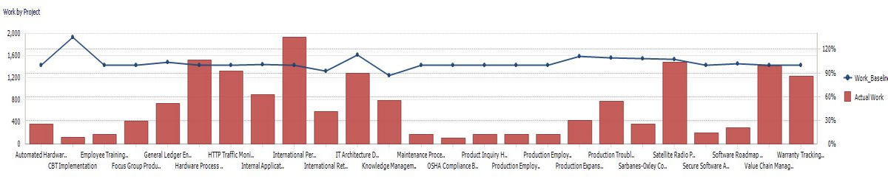
Figure 21 – Bar and Line Graph

MDX

with member [Measures].[Work_Baseline] as iif(coalesceempty([Measures].[Baseline Work],0)=0,null,
[Measures].[Actual Work]/[Measures].[Baseline Work]), format_string="Percent"
SELECT

filter(
HIERARCHIZE(
{ [Project List].[All Project List].CHILDREN } ),
coalesceempty([Measures].[Work_Baseline],0)<>0 )
ON COLUMNS,

{[Measures].[Work_Baseline, [Measures].[Actual Work] }
ON ROWS

FROM [MSP_Portfolio_Analyzer]
where <<Time>>

The logic is more complex but demonstrates the power of MDX with PerformancePoint. The MDX creates a new calculation called Work_Baseline which is a ratio between Actual Work and Baseline Work. The statement also filters out any Projects whose ratio of Work_Baseline is 0 or null.

While the analytical grids and graphs are part of PerformancePoint, there are several other items that can be included as a report. Those items include:

- Reporting Services
- Excel Services
- ProClarity Reports
- Web Pages
- Trend Analysis

Reporting gives the developers considerable flexibility to deliver the Project Server data to the users.

Dashboard

The dashboard is assembled from the scorecards and reports already created. The dashboard acts as the framework. The only new object that is created is the Filter object. A dashboard is then deployed to a SharePoint library.

The filter can then be linked to one or more objects on the dashboard.

Filters

Filters are dimension selections that can be applied to scorecards and reports. This is key functionality as it allows users the ability to navigate to prior time periods, review data from different parts of the organization, or any other dimension the developer desires.
In this case we will create a filter for time so the user can select different months.
There are several methods for creating filters.
- Member Selection: A list of members created directly from a dimension.
- MDX Query: An MDX expression that returns a set of values that the user can select. MDX query is identical to creating Set Formulas in the Scorecard section.
- Named Sets: Named sets are lists of dimension members that are created in the Analysis Services cubes. No Named Sets are created in the default Project Server cubes.
- Other methods include Tabular values and Time Intelligence — both of which are beyond the scope of this white paper.
Filters can be linked to any of the objects on the dashboard.

PerformancePoint Monitoring Conclusions

Dashboard Designer creates scorecards that allow users to quickly see the status of various projects. Through the use of targets and visual indicators, users can determine where they need to focus their attention. Prebuilt navigation paths provide a starting point for detailed analysis.

The Dashboard Designer can be used to create dashboards and scorecards for Project Server data that can be developed for many different user communities. Dashboards can support a project view for users where costs, risks, utilization and other project metrics are critical. Dashboards can also present a business objective view where projects are aligned with the business goals.

PerformancePoint Analytics

PerformancePoint Analytics is a major component of the PerformancePoint Server. Analytics, based on Microsoft ProClarity acquisition, is a robust ad-hoc query tool for use with Analysis Services. While Monitoring Server is designed for developers to create navigation paths through the data, Analytics is designed to give users fast and flexible access to the Project Server (or any Analysis Services) cube.

With Analytics users can explore the Project data for a better understanding of the data being presented in Monitoring Server. Users can also discover new relationships and trends that should be monitored.

Analytics has a flexible grid and graph and several advanced analytical visualization tools.

Grid
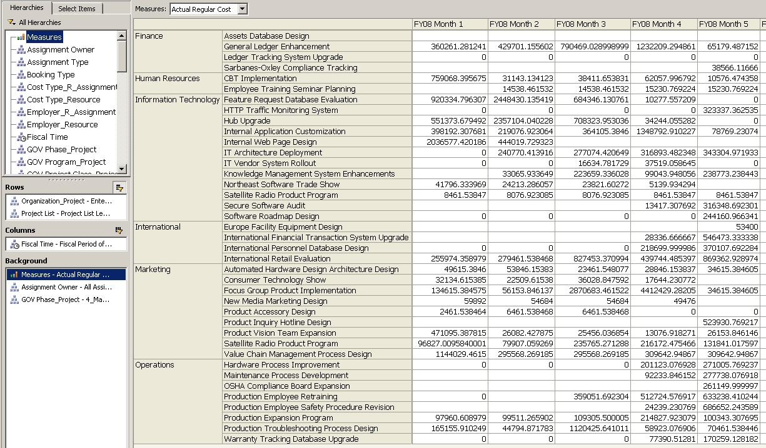
Figure 22 – PerformancePoint-Analytics Grid
The grid above displays the Organization and Project dimensions down the page and Fiscal Month across the page. The measure shown is Actual Regular Cost. Data can be further sorted, filtered and highlighted.

Analytics supports a large number of dimensions on reports as well as drill down and rotate. Users can also use analytical features.

Analytic Features

Users can filter any dimension for top/bottom, empty rows, Above or Below certain values.
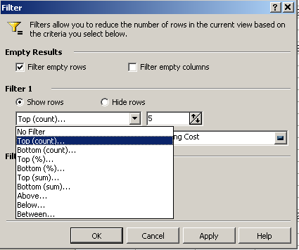
Figure 23 – PerformancePoint-Analytics Filter

Users can sort data on any column.

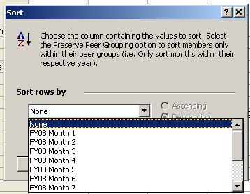
Figure 24 – PerformancePoint-Analytics Sorting

Below is the same report where the data has been sorted on Month 4 and the top 5 rows have been selected. The filtering and sort functions can be used together. This allows for advanced report creation without developers. The logic of the query is stored, not the results, allowing for users to execute the report as the data is updated.
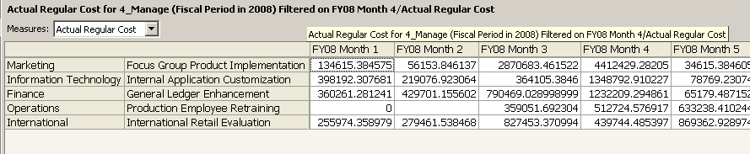
Figure 25 – PerformancePoint-Analytics Results

Visualization

Analytics also has robust advanced visualization functionality. Two of the advanced visualization tools are the Decomposition Tree and the Perspective graph. These tools give users new ways to investigate the data as they search for patterns in the data.

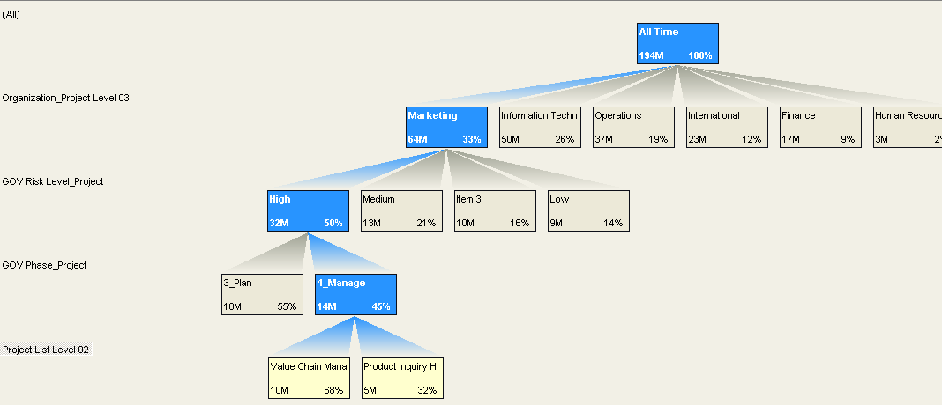
Figure 26 – PerformancePoint-Analytics Decomposition Tree
The tree shows the breakout of the Actual Cost measure along several dimensions. In this example, the Marketing Organization is broken out into Project Risk Level, Project Phase and then the Projects. The Value Change Management project is in the Marketing Organization, is High Risk and is being actively managed.

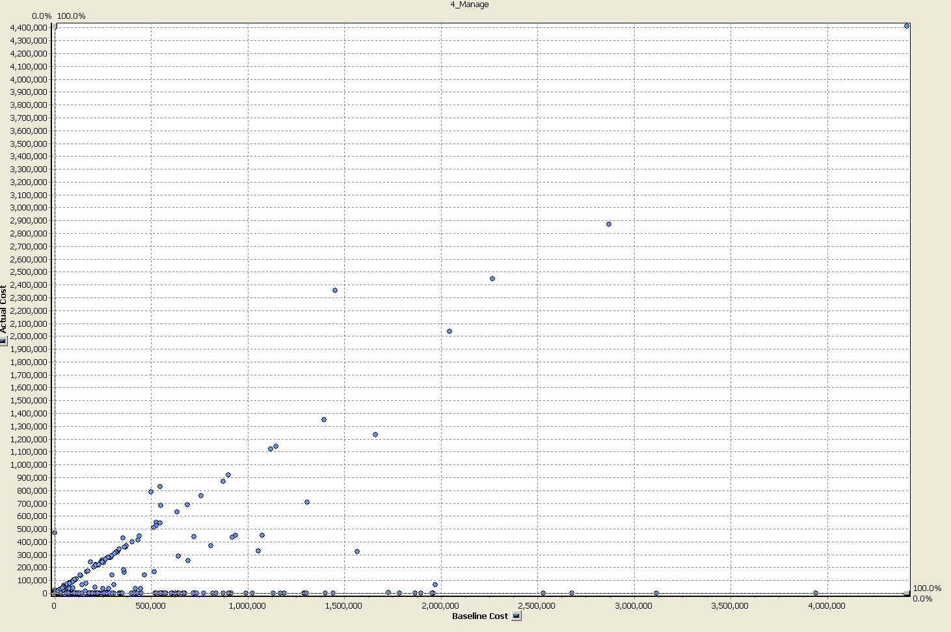
Figure 27 – PerformancePoint-Analytics Perspectives
Perspectives allow two measures to be displayed on each axis. In this example, Baseline Cost is compared with Actual Cost. Projects that exceed their Baseline will be above an invisible line that runs from the lower left corner to the upper right corner. A user can easily see which projects are over Baseline.

Calculations

Analytics gives users the ability to add their own calculations using a wizard. Users can extend the functionality of the database with new calculations. The wizard allows an end user to create calculations such as
- Growth – Year over Year Percent Change
- Time Series – Moving Averages, Year to Date, Quarter to Date
- Simple Relationships Ratio, Difference, Percent Difference
- Custom – Any MDX formula.
With a custom calculation, users can easily create a measure Total Costs with the following MDX:

[Measures].[Actual Cost]+
[Measures].[Actual Overtime Cost]+
[Measures].[Actual Regular Cost]

In the case of Growth and Time Series, both require a Time dimension. The following cubes do not have a time dimension.

- Assignment Non-Timephased
- Deliverables
- Issues
- Project Non-Timephased
- Resource Non-Timephased
- Risks
- Task Non-Timephased

These calculations are stored with the report definition and will not be lost when the cube is rebuilt.

PerformancePoint Analytics Conclusion

PerformancePoint Analytics is a robust ad hoc query tool. The Analysis Services engine provides fast performance and flexible navigation. With some training users can navigate the data without IT support. The ability for users to examine the data from many different dimensions is critical for problem investigation and opportunity discovery.

Summary

Project management data is comprised of a large set of interrelated numbers and complex calculations. Relationships between projects, tasks, owners and the success of the business are not always clear. While existing reports can meet many needs, PerformancePoint can clarify goals, project status, and project focus to the user community.

With Dashboard Designer a set of dashboards can be created to track projects and align them with corporate goals. Different user communities have different needs. To meet those needs, data from other systems, even Excel, can be integrated with the Project Server data.

By leveraging the out-of-the-box cubes, existing reports, and project management expertise with PerformancePoint software, a system can be built quickly. The system should be designed by both project management experts and end users. It is critical to drive the implementation from a business user point of view.

This white paper has only touched on the tools and techniques that can be used. Having a strong knowledge of Analysis Services, MDX and project management will be invaluable for a robust implementation.

Sample data files

Two sample data files are available for use with this document:

- ProClarity Briefing Book data file (ProjectServerProClarityWhitePaper.bbk) – This sample data file can be used in conjunction with the section titled PerformancePoint Analytics.

- PerformancePoint Monitoring data file (ProjectServerPerformancePointServerWhitePaper.bswx) – This sample data file can be used in conjunction with the sections titled PerformancePoint Server Monitor Architecture and Creating a Project Server Dashboard.

Both files are available for download through the Microsoft Download Center home page for this white paper. View the Readme document for instructions about using the sample data.

References

Microsoft Office Project Server 2007 TechCenter (TechNet): http://technet.microsoft.com/en-us/office/projectserver/default.aspx

Microsoft Office PerformancePoint Server 2007 TechCenter (TechNet): http://technet.microsoft.com/en-us/office/performancepoint/default.aspx

Project 2007 SDK: Software Development Kit (contains documented schemas of relational database and OLAP cubes)
http://www.microsoft.com/downloads/details.aspx?familyid=2672F6F9-7028-4B30-99A2-18CB1EED1ABE&displaylang=en

Enterprise Project Management VPC (for MS Partners):
https://partner.microsoft.com/us/40037763

MDX Solutions by George Spofford, et al.
http://www.amazon.com/MDX-Solutions-Microsoft-AnalysisServices/dp/0471748080/ref=pd_bbs_sr_1?ie=UTF8&s=books&qid=1229133641&sr=8-1

ASCMD – Utility for executing XMLA commands. http://www.codeplex.com/MSFTASProdSamples/Wiki/View.aspx?title=Katmai!Readme%20For%20Command-line%20Utility%20Sample

PerformancePoint Monitor Scoring Engine:
http://blogs.msdn.com/performancepoint/archive/2008/01/18/scoring-algorithm-used-in-performancepoint-scorecards.aspx

Project Server and PerformancePoint Virtual Labs:
http://msevents.microsoft.com/CUI/WebCastEventDetails.aspx?EventID=1032368324&EventCategory=3&culture=en-US&CountryCode=US

Project Server Cube building service notes on TechNet:
http://technet.microsoft.com/en-us/library/cc197625.aspx

Symmetry Corporation:
http://www.symcorp.com

